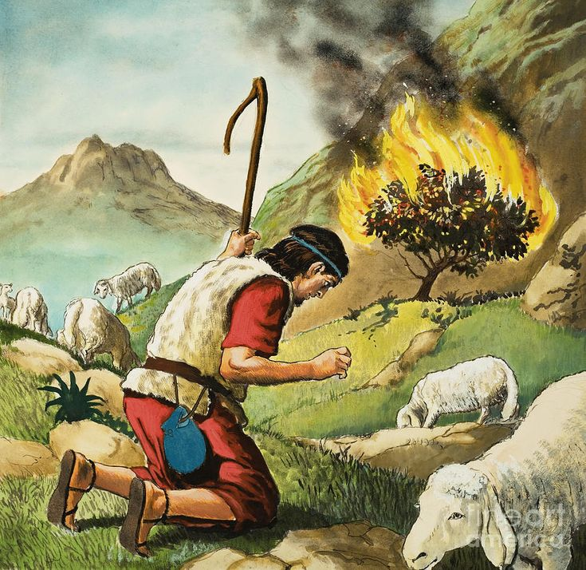
MOSES AND THE BURNING BUSH IMAGE

